**Dental Care Supply**

**Tennessee (TN) Notes**

**by Chris Larkins**

* I used a new TN_Dentist file downloaded on 5.20.20. from TN department of Health for the most updated list of BOD dentists. The BOD file on Dropbox is currently from 2019. <https://apps.health.tn.gov/licensurereports/default.aspx>
* The “IKN_processed.csv” file and “[NP_national_w_extra_col_2n.csv](http://localhost:8888/view/Dental%20Care%20Supply/NP_national_w_extra_col_2n%20(1).csv)” files were used
* Anything that mentioned “hygienist” was disregarded according to recent dropbox updates.
* I used the PA/IL code on dropbox to help formulate my code for TN
* After going back and now including the NULL states in the MED and CHIP processing, the final MED + CHIP + FTE sum of dentists came to be 3,051 (2,981 unique). This compares to be far less than the ADA total supply of dentists in 2018 which 3,349. Before adding the NULL states and adding the addressed from the old BOD data, the total was 2,851.
* This original BOD file from 5.20.20 includes:
  + 4,640 rows of Dentists, without any hygienists.
  + Only dentists with active, un-expired licenses.
  + 3473 (75%) rows have a TN practice state.
  + **867 (19%) rows had a NULL practice state.**
    - **Null states were removed in BOD-pre-processing.**
    - **I believe this is a major reason why the sum of BOD, Med, and CHIP final FTE files came to be 2,853 which is far less than the 2018 ADA TN dentists of 3,349. Somehow in the future, the null states need to be distinguished whether the dentist is in state or not. From initial investigation, it appears that many of the NULL states are TN dentists. If this is not the issues, that it could be that I pulled the wrong set of dentists from:** <https://apps.health.tn.gov/licensurereports/default.aspx>
    - **When you go to retrieve dentists from the website, and select dentists “in-state” it still gives you dentists from many different states. This is something not right about the results it gives.**
    - **From Grace’s recommendation, I used the BOD data from 2019 on dropbox to retrieve addresses that were not showing up on the latest 2020 version. The python script for this is in the Tennessee matched_files folder. This allowed me to retrieve 47 more addresses. 41 of which has TN practice states.** 
      * **This did not affect the Med/Chip calculation, but it did affect the BOD stand alone.**
  + The Columns Headers Include:
    - *Board Profession Rank LastName FirstName MiddleName Title LicenseNumber ExpirationDate OriginalDate Status LicenseActivity StatusEffectiveDate Disciplined ModifierDescription ModifierType PracticeName PracticeAddress PracticeAddress2 PracticeCity PracticeState PracticeZIP PracticeAreaCode PracticePhoneNumber PracticeExtension PracticeCounty*
  + 278 (6%) rows were found in which *PracticeAddress* column did not include a number, and the *PracticeAddress2* column did. I edited these 278 addresses in the original TN_Dentist file to include actual addresses for the *PracticeAddress* column. Many of these rows included the name of the location rather than the address. For example:
    - “Randolph Air Force Base”
    - “ATKINSON FAM. DENTISTRY,P.C.”
    - “UNIV OF TN COLLEGE OF DENTISTR”
  + A “*LicenseActivity*” column which denotes dentists as one of the following: [“Working Full Time”, “Part Time”,”Act St Unknown”, “AS Not Reported”, “Not Reported,” Not Practicing”]
  + 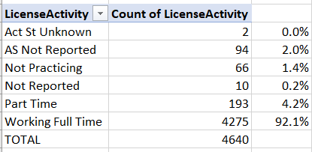
    - The sum of the “Part Time” and “Working Full Time” Dentists with a *PracticeState* in TN is 3382. According to the 2018 ADA report, 3349 dentists worked in dentistry in 2018. Therefore:
      * Only the “Part Time” and “Working Full Time” Dentists were kept after the exclusions phase.
    - 175 unique “Part Time” dentists in original BOD file
    - 47 unique “Part Time” dentists after exclusions
    - 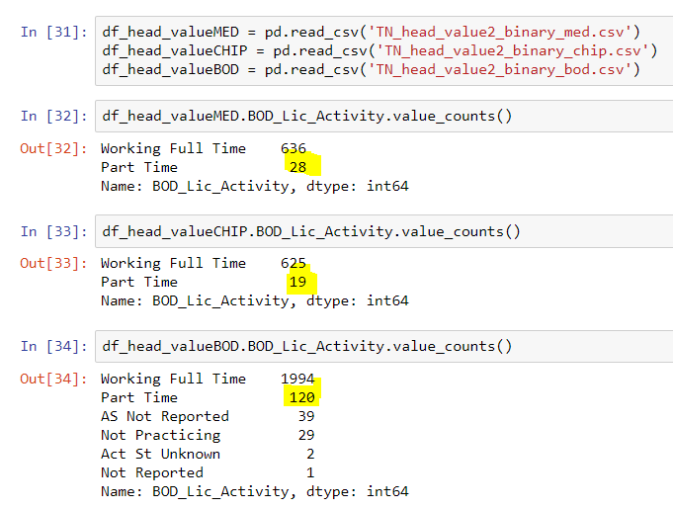
* The IKN-NPPES match rate was 97.3%
* The IKN overall match rate 74.4%.
  + After validation, it appeared that names did not match because the name either did not exist in the BOD, or there was a middle name, or a misspelling. Overall, common errors.
* File was split into MED and CHIP at the end of the exclusions phase
* All of the rows for the final BOD FTE sum had whole numbers for the general, specialist, and pediatric columns.
* During the BOD stand alone process, one person who had a “Retired” address was removed from the dataset.